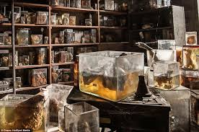
Frankenstein

A description of the laboratory

 | high | electrical-looking | preserved | white
shabby | large | arched | cluttered | linen
machine | laboratory | windows | sitting room | specimens | sheet

Text
The room has high, arched windows through which can be seen mountains and forest. On a bench at the back lies something – obviously the monster – covered by a white linen sheet. The room is an odd mixture of shabby sitting room and cluttered laboratory. Phials and bottles of chemicals and preserved specimens of various kinds line the shelves. A large, electrical-looking machine stands in the corner.

